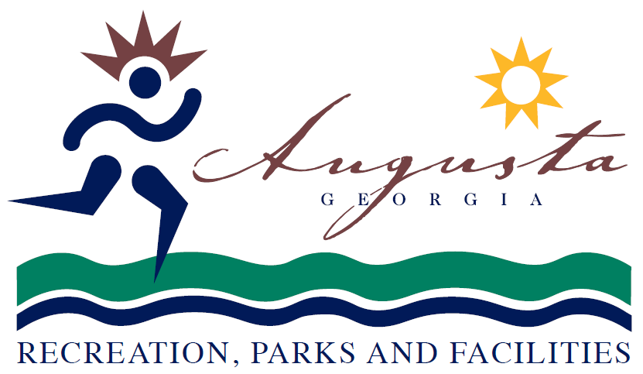 

2015 State Track – Motel Accommodations

Clarion Suites

3038 Washington Road

Augusta, GA 30907

(706) 868-1800

Courtyard by Marriott

1045 Stevens Creek Road

Augusta, GA 30907

(706) 737-3737

Doubletree by Hilton – Opal Blanding

2651 Perimeter Parkway

Augusta, GA 30909

(706) 860-9414

Hampton Inn & Suites

4081 Jimmy Dyess Parkway

Augusta, GA 30909

(706) 860-1610

Hampton Inn

3030 Washington Road

Augusta, GA 30907

(706) 737-1122

Holiday Inn Express

1073 Stevens Creek Road

Augusta, GA 30907

(706) 396-3000

Holiday Inn West

441 Park West Drive

Augusta, GA 30813

(706) 396-4600

Jameson Inn & Suites

1062 Claussen Road

Augusta, GA 30907

(706) 733-4656

Laquinta Inn

3020 Washington Road

Augusta, GA 30907

(706) 733-2660

Quality Inn & Suites

1052 Claussen Road

Augusta, GA 30907

(706) 737-5550

Sheraton Hotel Augusta - Sales

1069 Stevens Creek Road

Augusta, GA 30907

(706) 396-1000

Sleep Inn

1050 Claussen Road

Augusta, GA 30907

(706) 738-7473

Wingate by Wyndham

4087 Jimmy Dyess Parkway

Augusta, GA 30909

(706) 860-8223